**Final Report (Close-Out Memo)**

**Date:** 4/24/2024

**Written by:** Elijah Widener Ferreira

**Use Case Name (Spreadsheet Title):** Extend research paper's RUL prognostics code to other datasets to show general applicability

**Reviewed by:**

**Use Case Description**

This project concentrated on replicating and validating the findings of a seminal research paper on predictive maintenance using data-driven probabilistic Remaining Useful Life (RUL) prognostics for aircraft turbofan engines. The objective was to implement a convolutional neural network (CNN) as described in the study, to assess its effectiveness in a real-world scenario using the C-MAPSS dataset. This replication effort was critical for confirming the reliability and applicability of the proposed model in forecasting the lifespan of engine components under varied operational conditions.

By accurately reproducing the paper’s methodology, we aimed to demonstrate the model's capability to not only predict the timing of potential component failures but also to evaluate the confidence levels of these predictions. This approach supports more precise and cost-effective maintenance scheduling, enhancing operational efficiency and safety. The work underscores the importance of robust validation practices in the predictive maintenance field, ensuring that theoretical models hold up under practical examination and provide tangible benefits.

**Dataset**

The dataset used for this project is the C-MAPSS dataset, which contains sensor data from aircraft engines under various operational conditions. This data is crucial for training The predictive model to accurately forecast RUL based on real-world engine behavior.

Location of the dataset: https://github.com/TheBriteGroup/Elijah/tree/main/Assigned/CNN/Data

**Code Description**

Several Python scripts form the backbone of the project's codebase:

* CNN.py: This script contains the CNN model's architecture and training procedures.
* data_prep.py: Handles preprocessing of the C-MAPSS dataset, including normalization and partitioning into training and testing sets.
* evaluate.py: Used for evaluating the model's performance on the test set, calculating metrics such as RMSE and probabilistic RUL estimates.
* RUL_metrics.py: Implements additional metrics for assessing the uncertainty and accuracy of the RUL predictions.
* All scripts are well-documented and include comments explaining each step of the process.

**Code Implementation**

The implementation phase of the project involved several steps in setting up and executing the convolutional neural network (CNN) model as prescribed by the original research paper. One of the major challenges we encountered during this phase was related to the preprocessing of the C-MAPSS dataset, specifically in terms of data normalization.

Initially, the attempts to manually normalize the sensor data did not yield consistent results with those presented in the research paper. Discrepancies in the normalization process affected the model's performance, difficult to accurately evaluate the model. After several trials and a detailed review of the normalization procedures, it became evident that achieving the exact preprocessing conditions used in the study was crucial.

To resolve this issue and ensure fidelity in replication, we opted to use the pre-normalized data provided by the authors of the research paper. This dataset had been processed to maintain consistency with the operational conditions outlined in the study, ensuring that the input data to the CNN model closely matched the conditions under which the original results were obtained.

**Results and Findings**

The CNN model demonstrated high accuracy in predicting the RUL of turbofan engines, with the probabilistic approach providing not only point estimates but also confidence intervals, which are crucial for maintenance planning.  
  
All of the results are in this file : [link](https://github.com/TheBriteGroup/Elijah/blob/main/Assigned/CNN/evaluate.py)  
Here are some figures:  
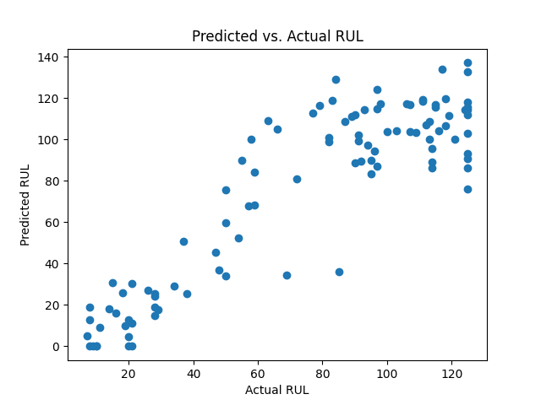

**Conclusions and Future Works**

The project establishes a robust framework for predictive maintenance using deep learning and probabilistic modeling. Future work will focus on extending the model to other types of machinery and integrating real-time data feeds to allow dynamic prediction updates.

Future Directions:

* Expand the model's applicability to other industrial applications.
  + PRONOSTIA Bearing Dataset
  + Lithium-Ion Batteries
* Enhance the model's time data processing capabilities.